**Report 2 Database Kindergarten Project**

**Jonathan Solis**

**Professor Darwish**

**CSCI 5203**

**Project goals:**

* The goal of this project was to build a database for elementary school, specifically kindergarten classes.Before building the database, I needed to make a list of the relation I wanted in my database, I created the database once I figured that out along with the attributes and the datatype for each attribute. Once I created the database the entity relationship diagram (ERD) was made through MySQL. Once I planned to code data into the relations. After this was completed my end goal was to be able to perform the queries I needed to run, then retrieve the data based on my query. This was the goal, a working database.

**Database description:**

* The database consists of 10 relations that cover elementary kindergartens. The data that is stored in the database is Clubs, joined clubs, family contact, family number, family contacts with students, health record, students, tests, students with test, and teachers. This database will benefit the user by helping them be able to link tables and connections, find relations, and retrieve the data they need from the database.

**Data model & design:**

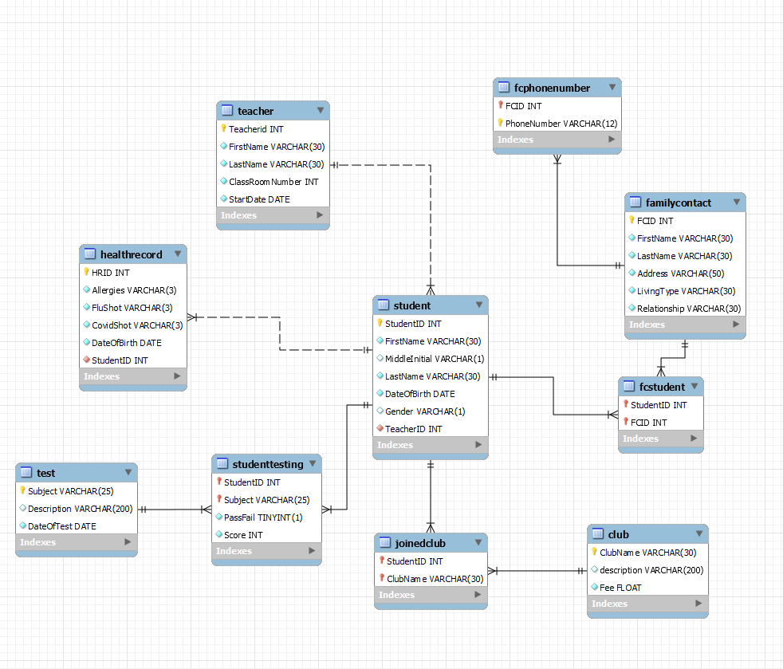

**Business Rules:**

**Data dictionary:**

1. ***Club***

* **ClubName** Varchar(30) (PK) [Names of each club]
* Description Varchar(200) [Small description of each club]
* Fee Float [Cost of each club for entry fee]

1. ***JoinedClubs***

* **StudentID** INT (PK) (FK) [ID of each student] 🡨

Composite PK

* **ClubName** Varchar(30) (PK) (FK) [Names of each club] 🡨

1. ***Student***

* **StudentID** INT (PK) [ID of each student]
* FirstName Varchar(30) [First name of each student]
* Middleinitial Varchar(1) [First initial of each student middle name]
* LastName Varchar(30) [Last name of each student]
* DateOfBirth DATE [Birth date of each student]
* Gender Varchar(1) [Gender of the student]
* TeacherID INT (FK) [ID of each teacher]

1. ***FCStudent***

* **StudnetID** INT (PK) (FK) [ID of each student] 🡨

Composite PK

* **FCID** INT (PK) (FK) [Family Contact ID of each family member listed]🡨

1. ***FamilyContact***

* **FCID** INT (PK) [Family Contact ID of each family member listed]
* FirstName Varchar(30) [First name of each family member listed]
* LastName Varchar(30) [Last name of each family member listed]
* Address Varchar(50) [Home address of the family member listed]
* LivingType Varchar(30) [House or apartment]
* Relationship Varchar(30) [The relationship they have with the student]

1. ***FcPhonenumber***

* **FCID** INT (PK) (FK) [Family Contact ID of each family member listed] 🡨

Composite PK

* **PhoneNumber** Varchar(12) (PK) [Phone Number of the family member] 🡨

1. ***Teacher***

* **TeacherID** INT (PK) [ID of each teacher]
* FirstName Varchar(30) [First name of each teacher]
* LastName Varchar(30) [Last name of each teacher]
* ClassRoomNumber INT [The classroom number the teacher has]
* StartDate DATE [The day the teacher started teaching at the school]

1. ***HealthRecord***

* **HRID** INT (PK) [Health record of each student]
* Allergies Varchar(3) [Yes or no on if they have allergies]
* FluShot Varchar(3) [Yes or no on if they have a flu shot]
* CovidShot Varchar(3) [Yes or no on if they have covid shot]
* DateOfBirth DATE [Birth date of each student]
* StudentID INT (FK) [ID of each student]

1. ***StudentTesting***

* **StudentID** INT (PK) (FK) [ID of each student]🡨

Composite Primary Key

* **Subject** Varchar(25) (PK) (FK) [The different subjects] 🡨
* PassFail TINYINT(1) [If the student passed or failed]
* Score INT [The score they got on the test]

1. ***Test***

* **Subject** Varchar(25) (PK) [The different subjects]
* Description Varchar (200) [Description of the test]
* DateOfTest DATE [The date of each test]

**Implementation:**

*Use MySQL Server and MySQL Workbench to create the database/tables. Include a snapshot of the SQL code in your report.*

* Teacher table code

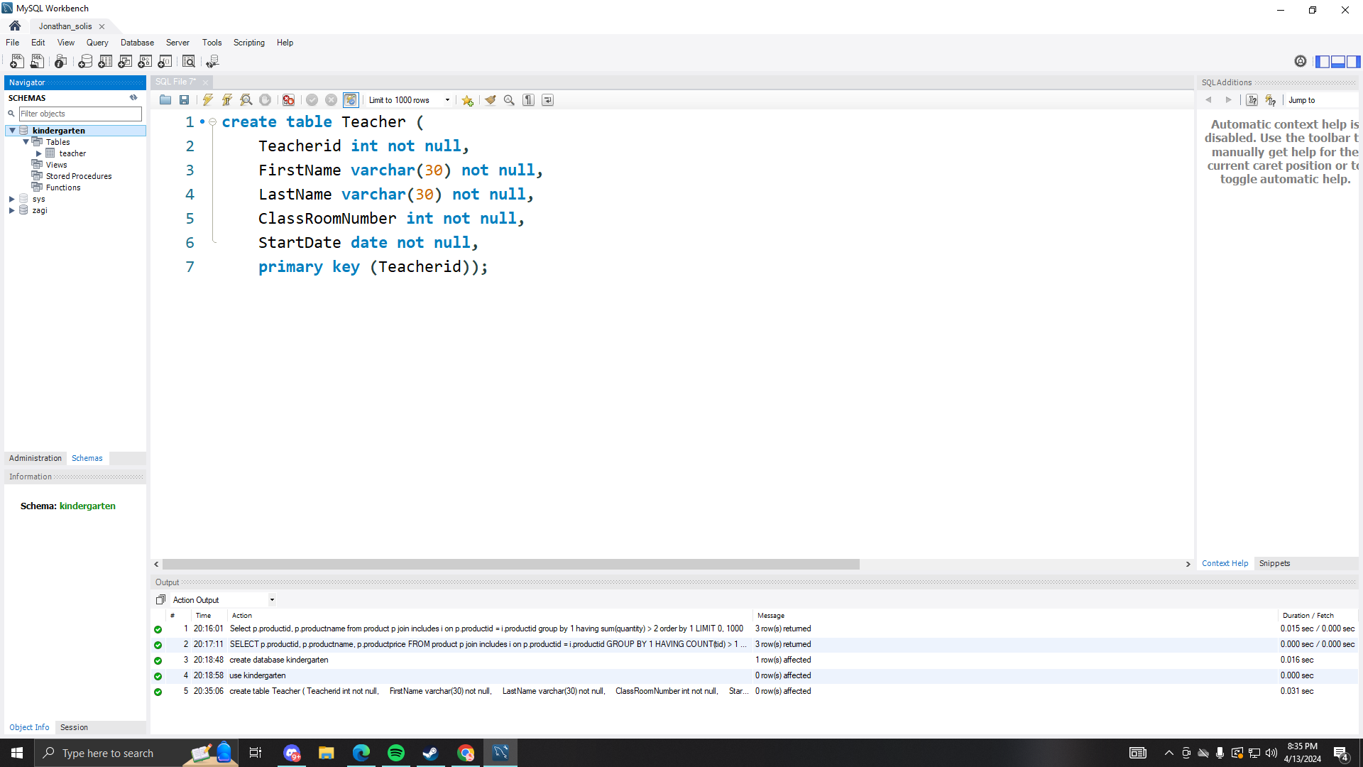

* Student table code

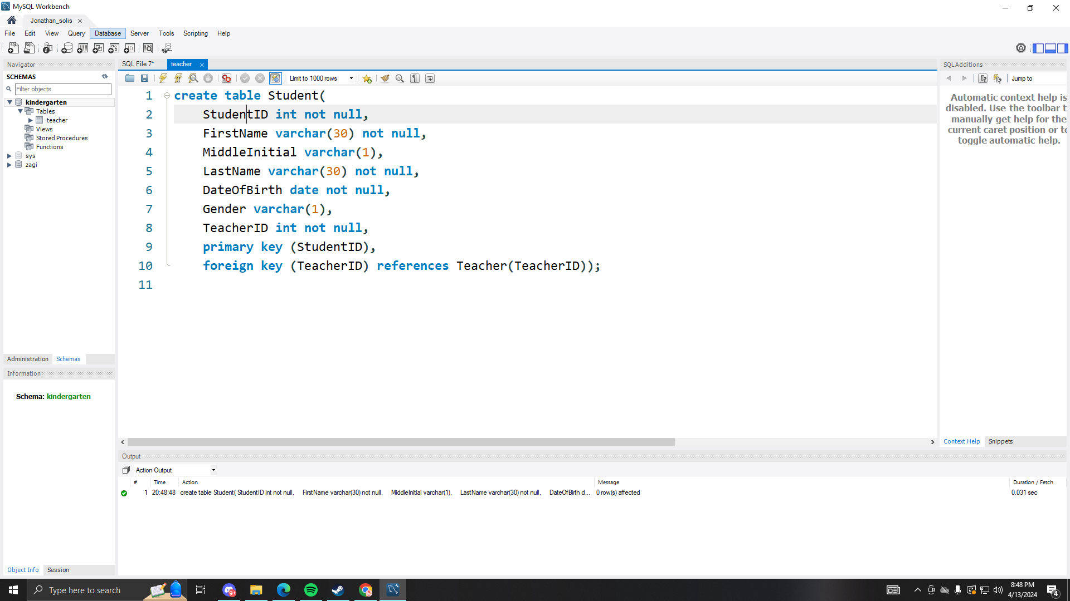

* HealthRecord table code

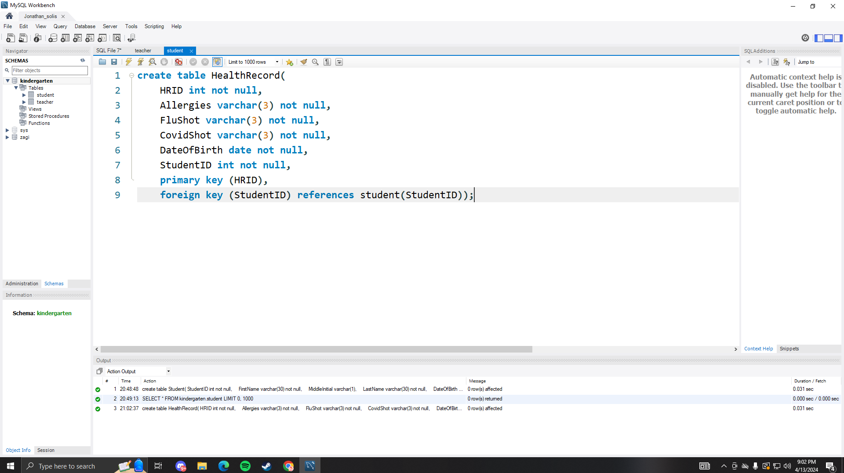

* FamilyContact Table code

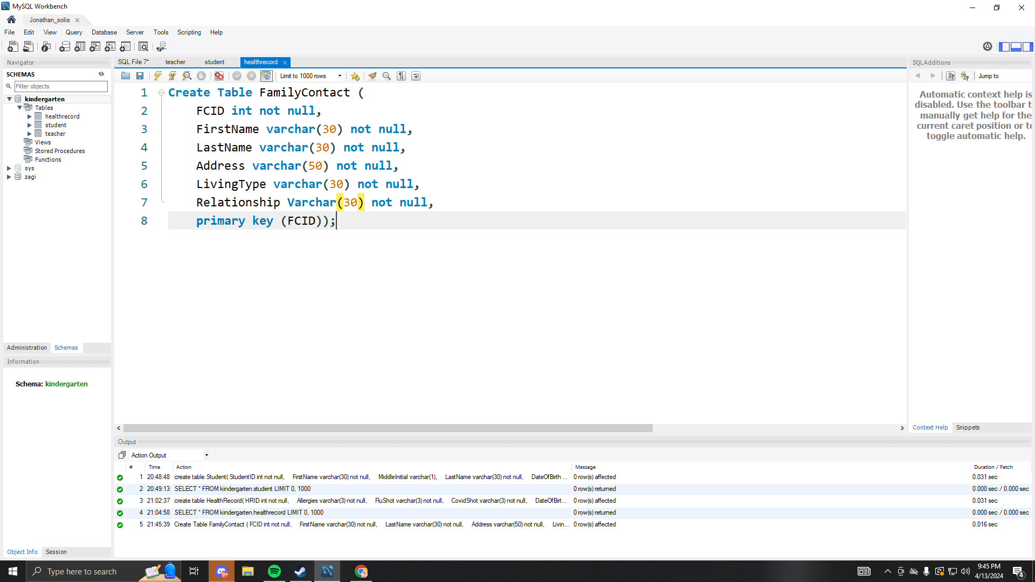

* FCPhoneNumber Table code

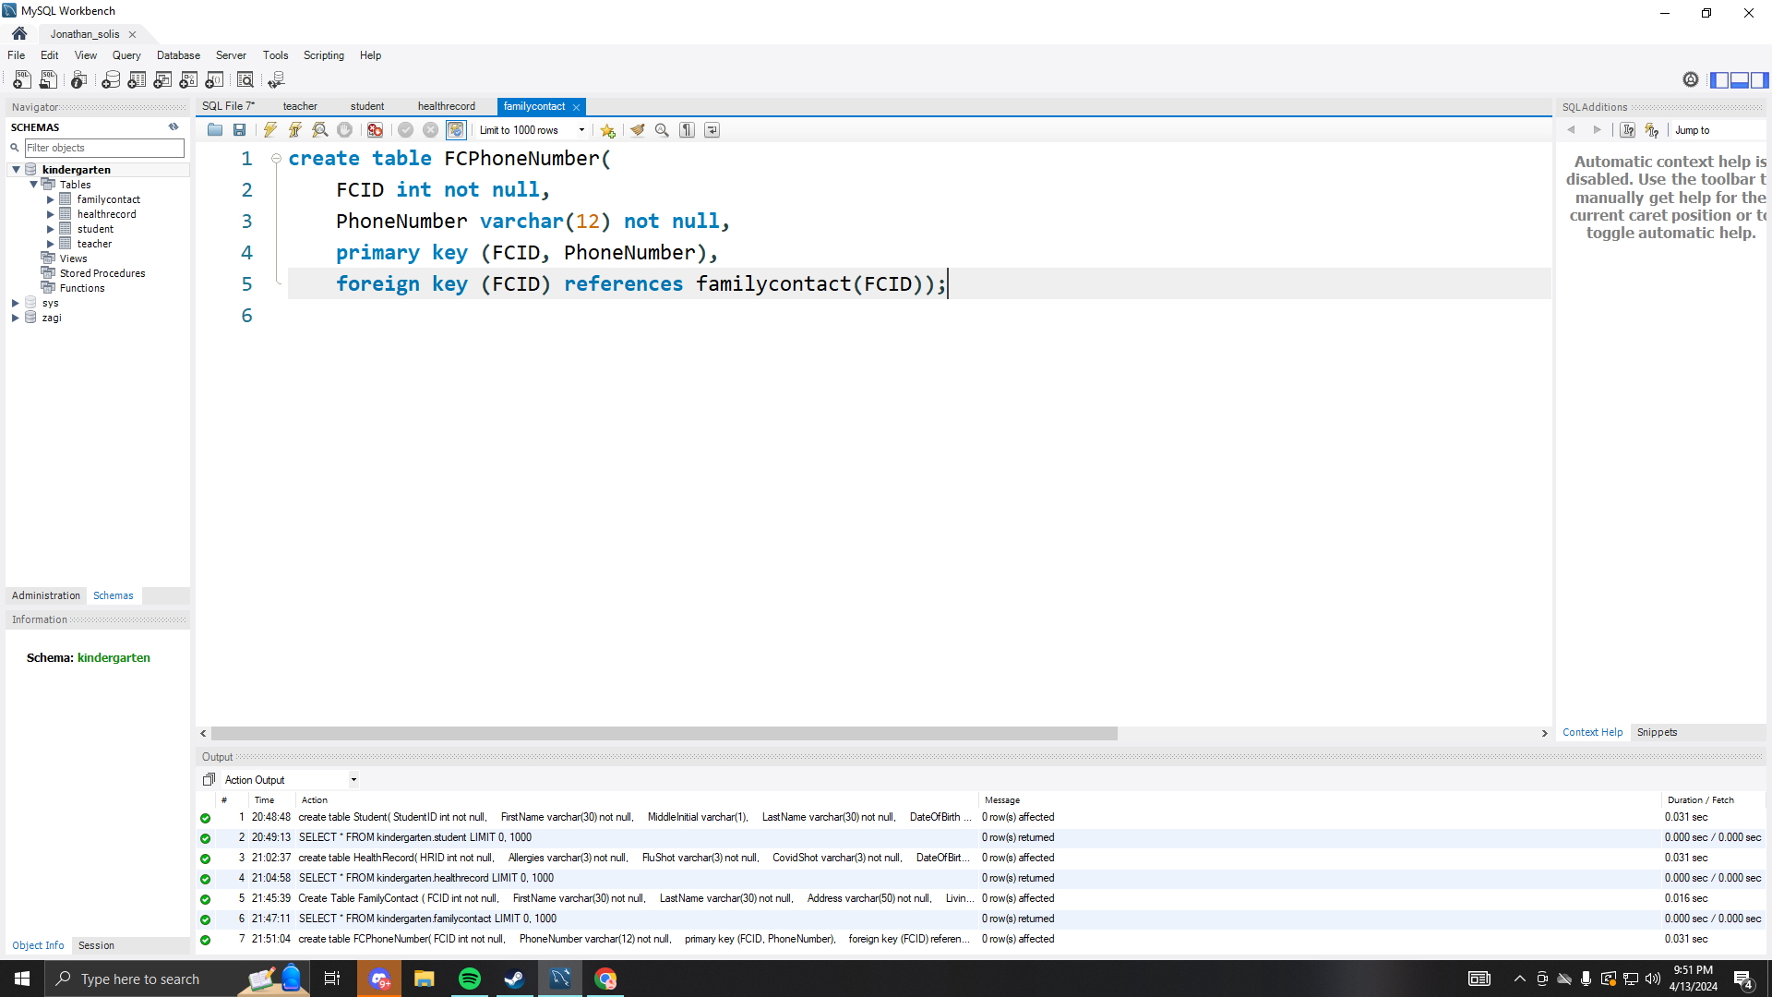

* FCStudent table code

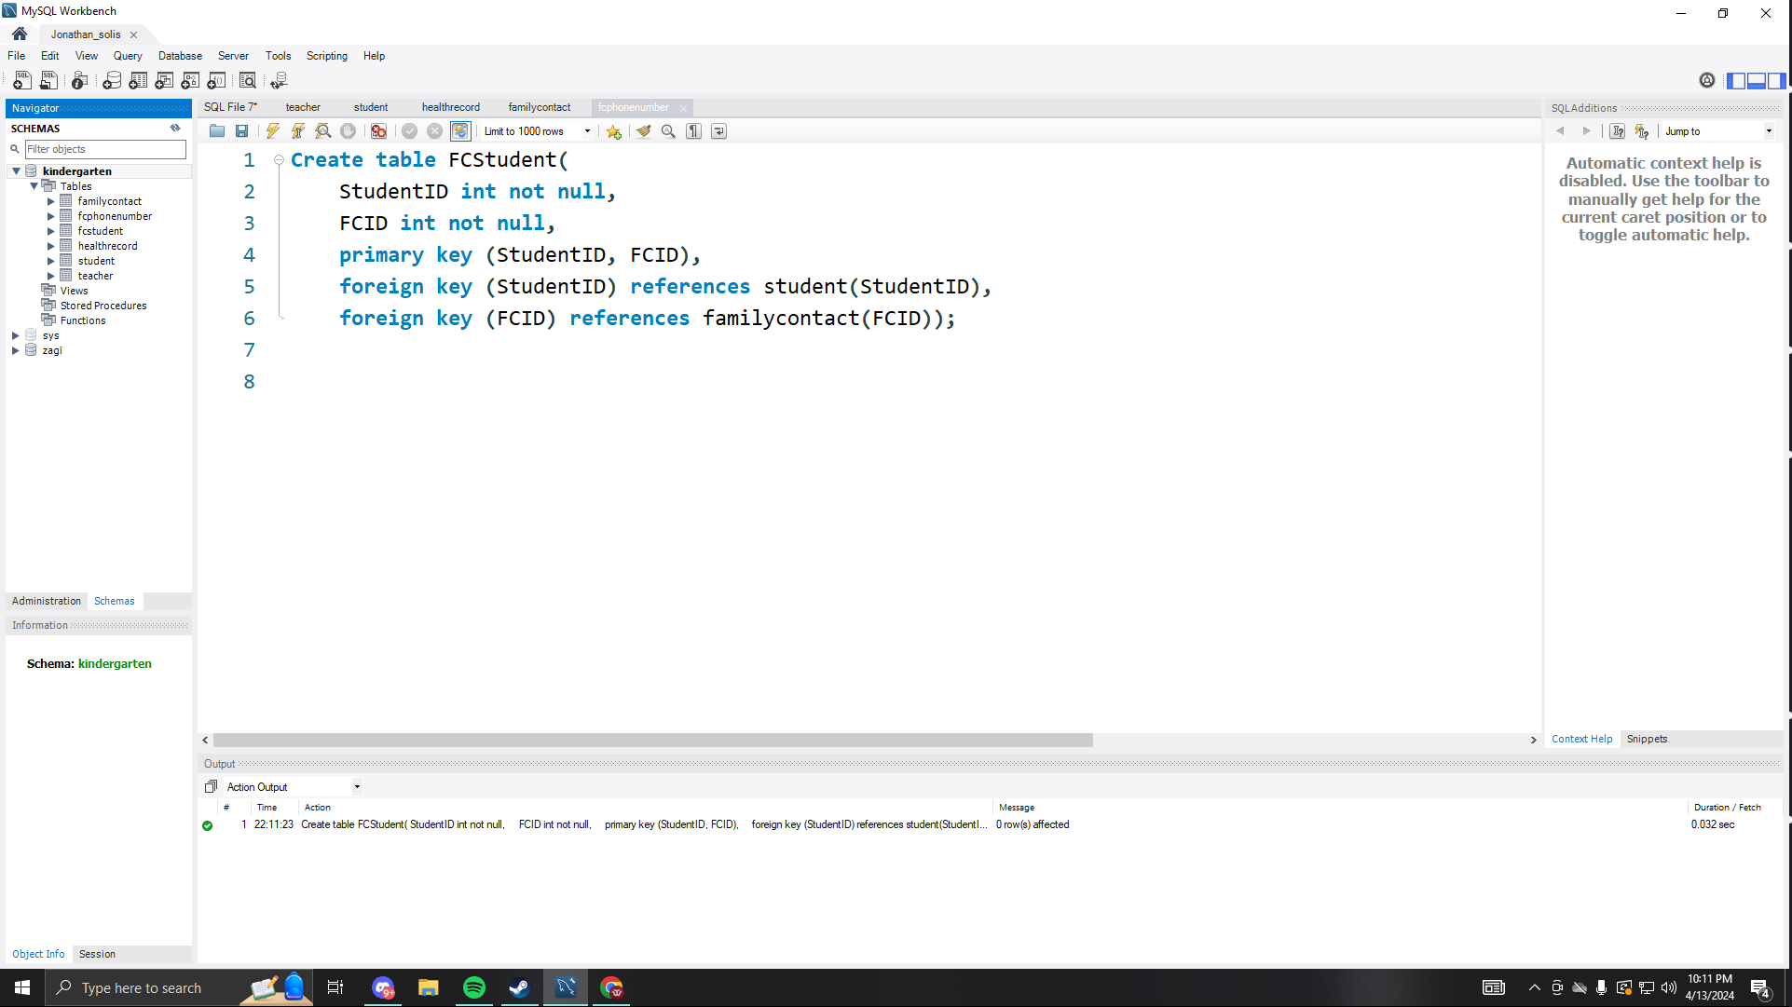

* Test table code.

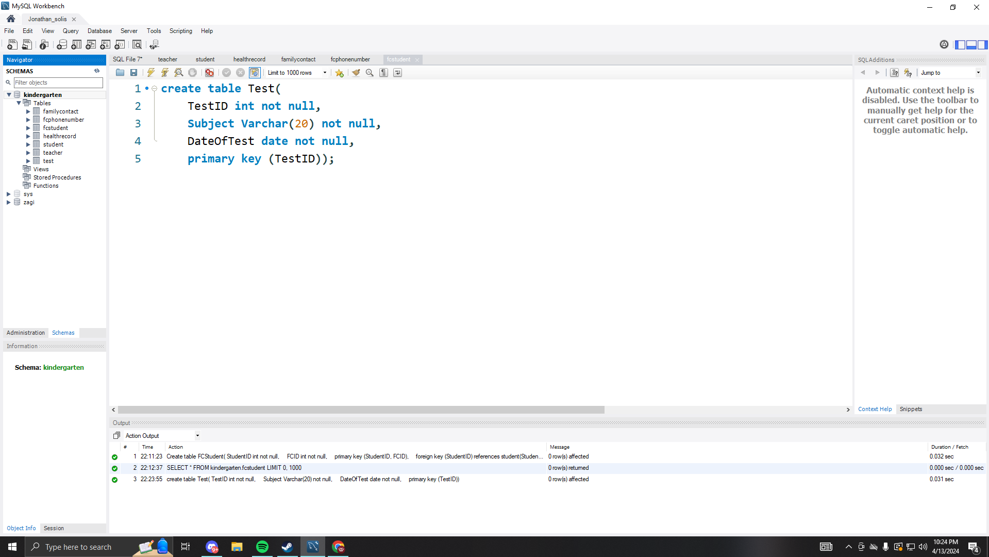

* StudentTesting table code.

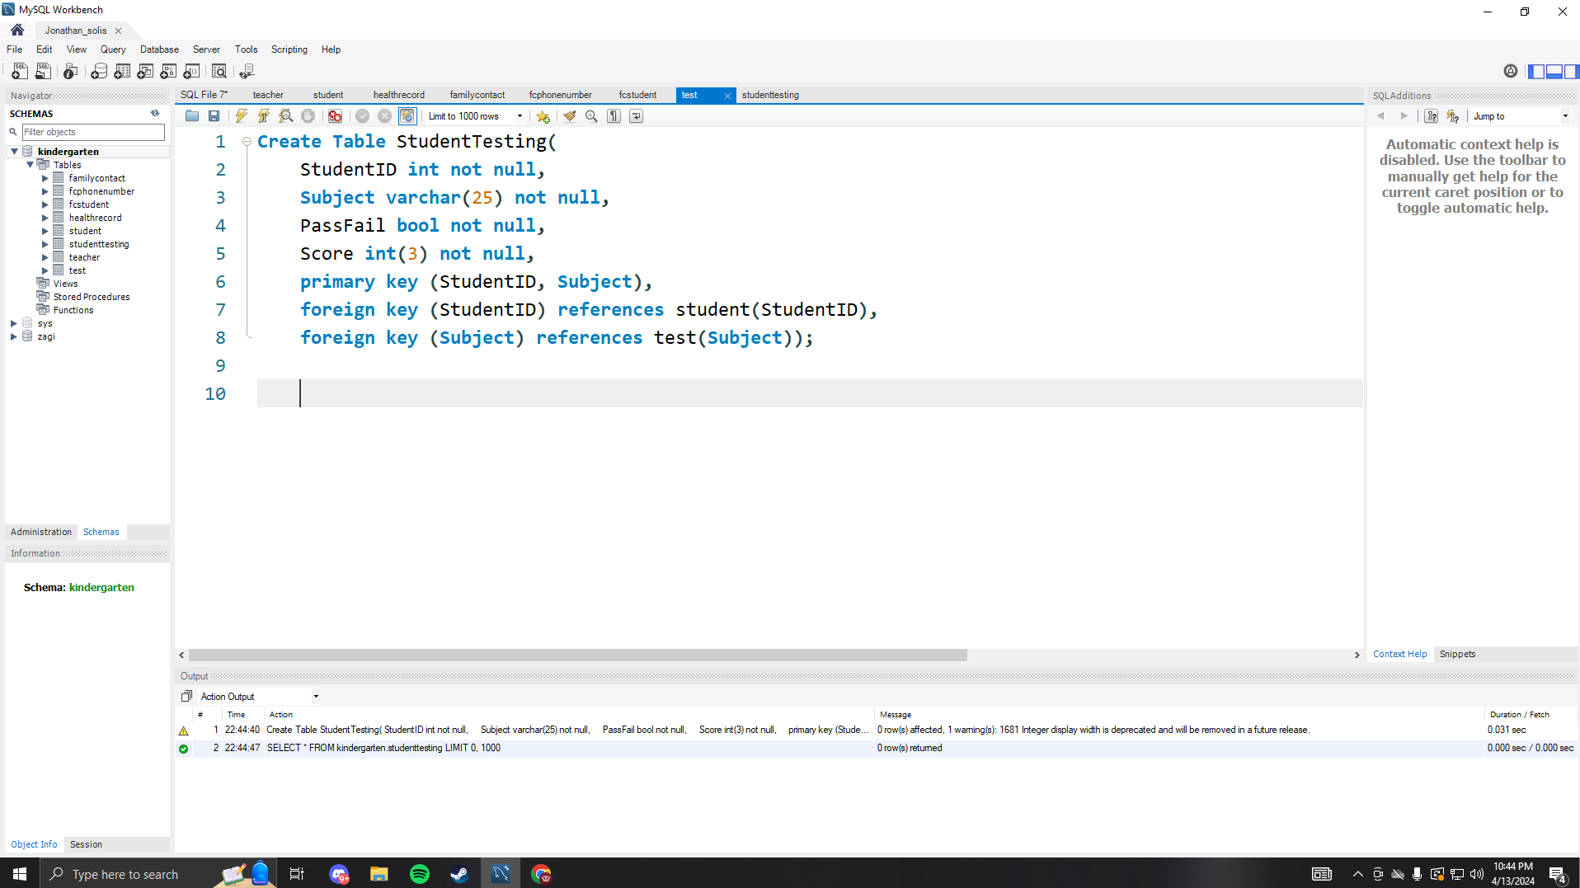

* Club table code.

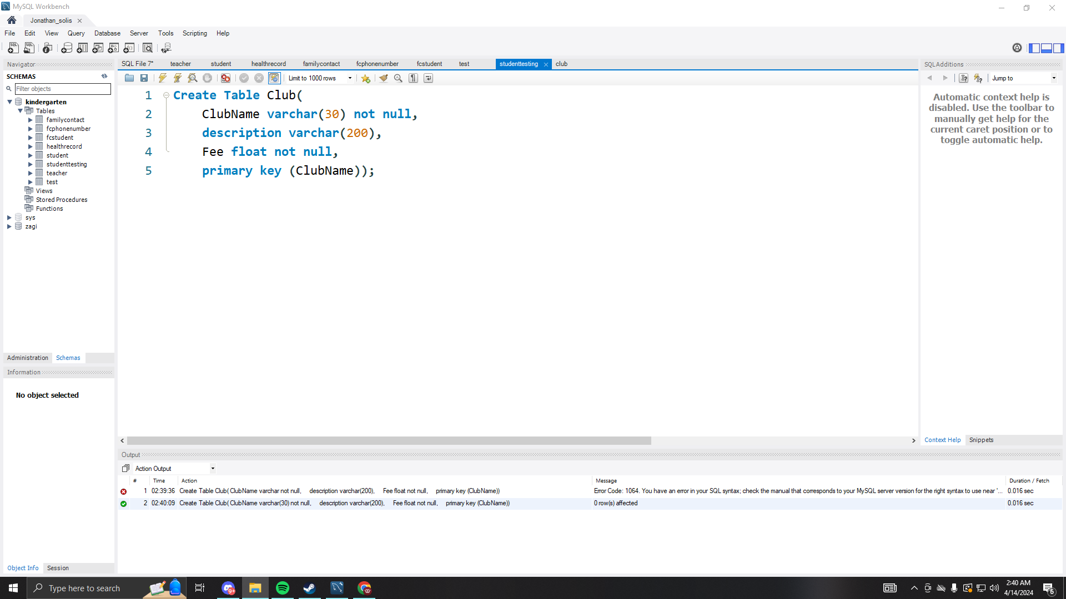

* JoinedClub table code

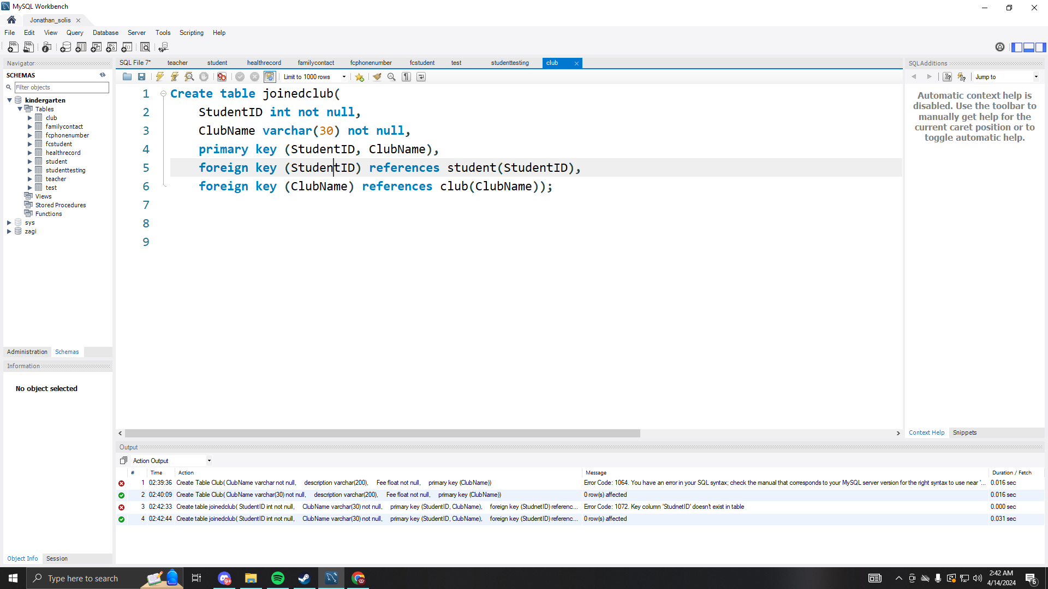

*Populate each table with a minimum of 20 rows of sample data. Make sure the  
entered data is descriptive (not just random numbers and letters. Include a snapshot of the SQL code in your report*.

* Teacher data code

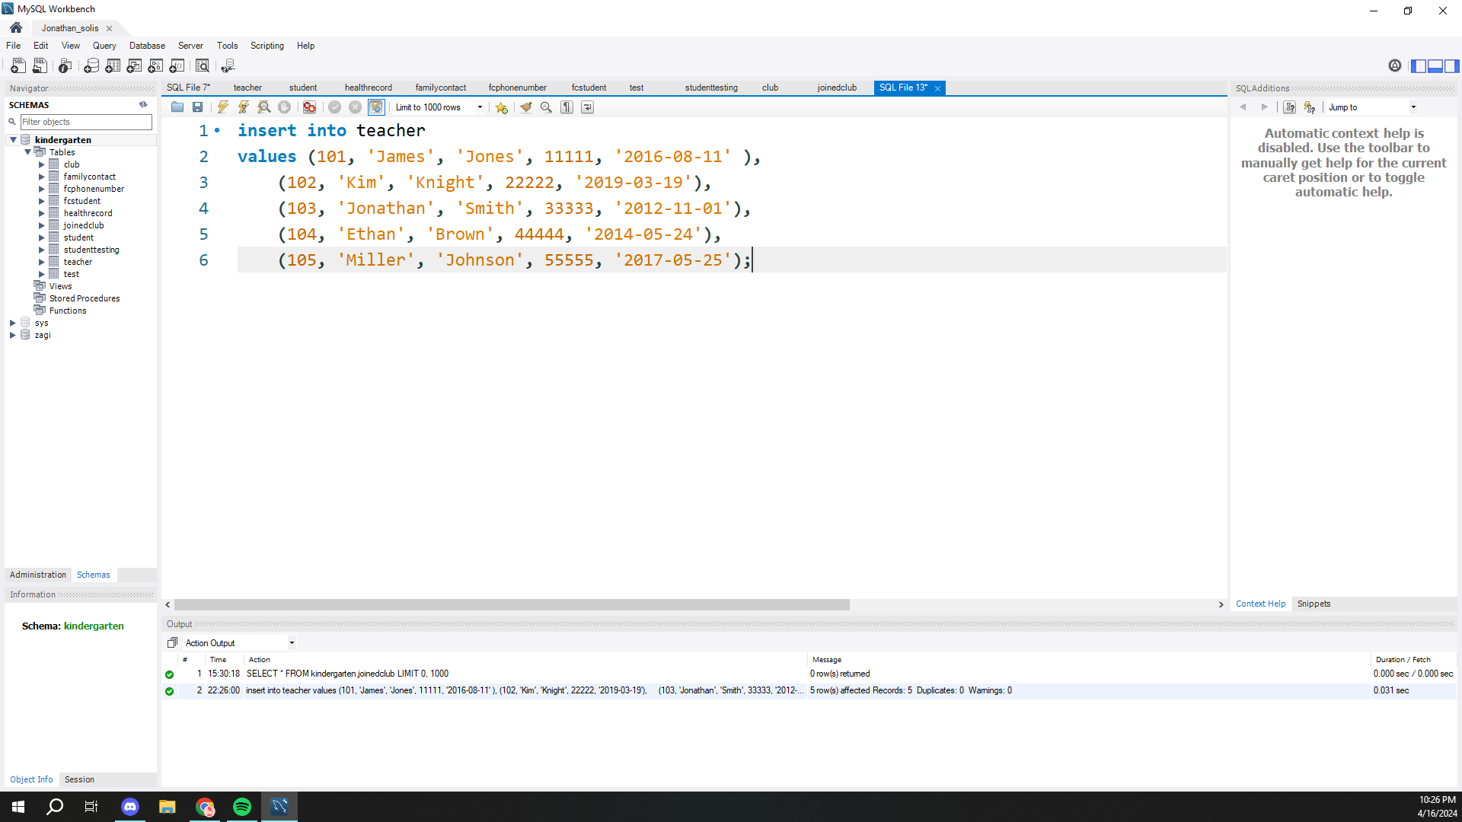

* Student data code

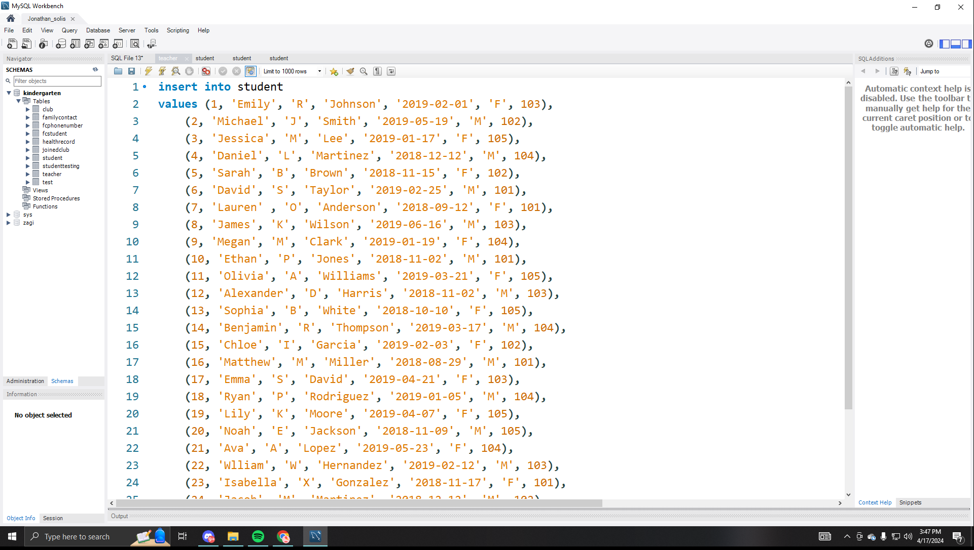

* HealthcareRecords Data code

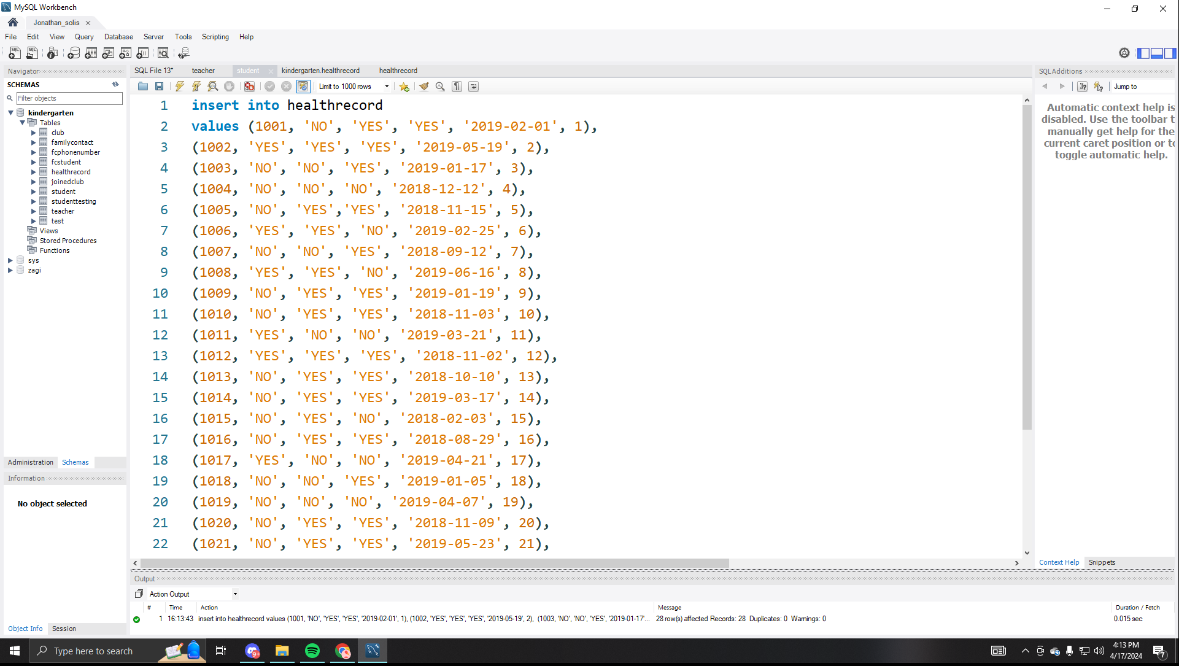

* FamilyContact data code

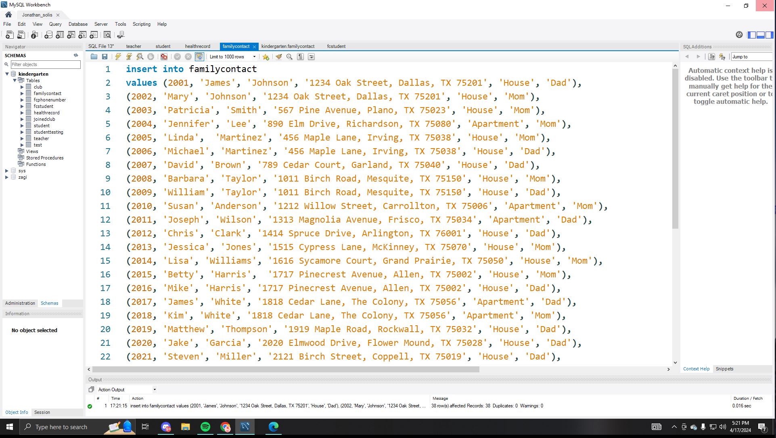

* FCPhoneNumber data code

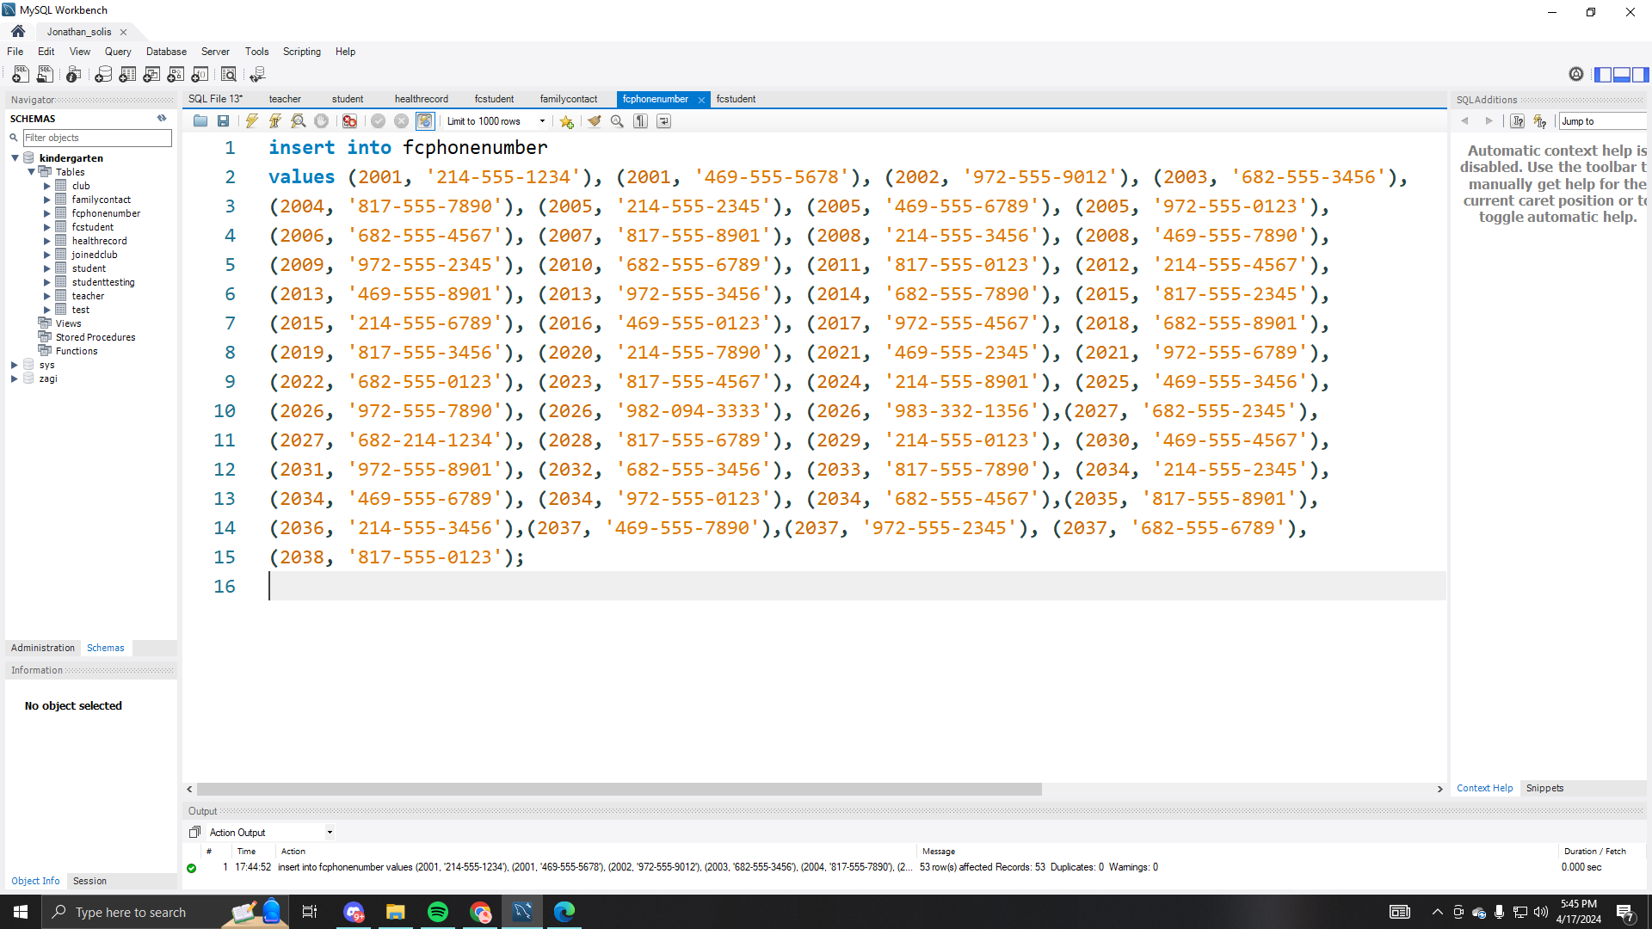

* FCStudent data code

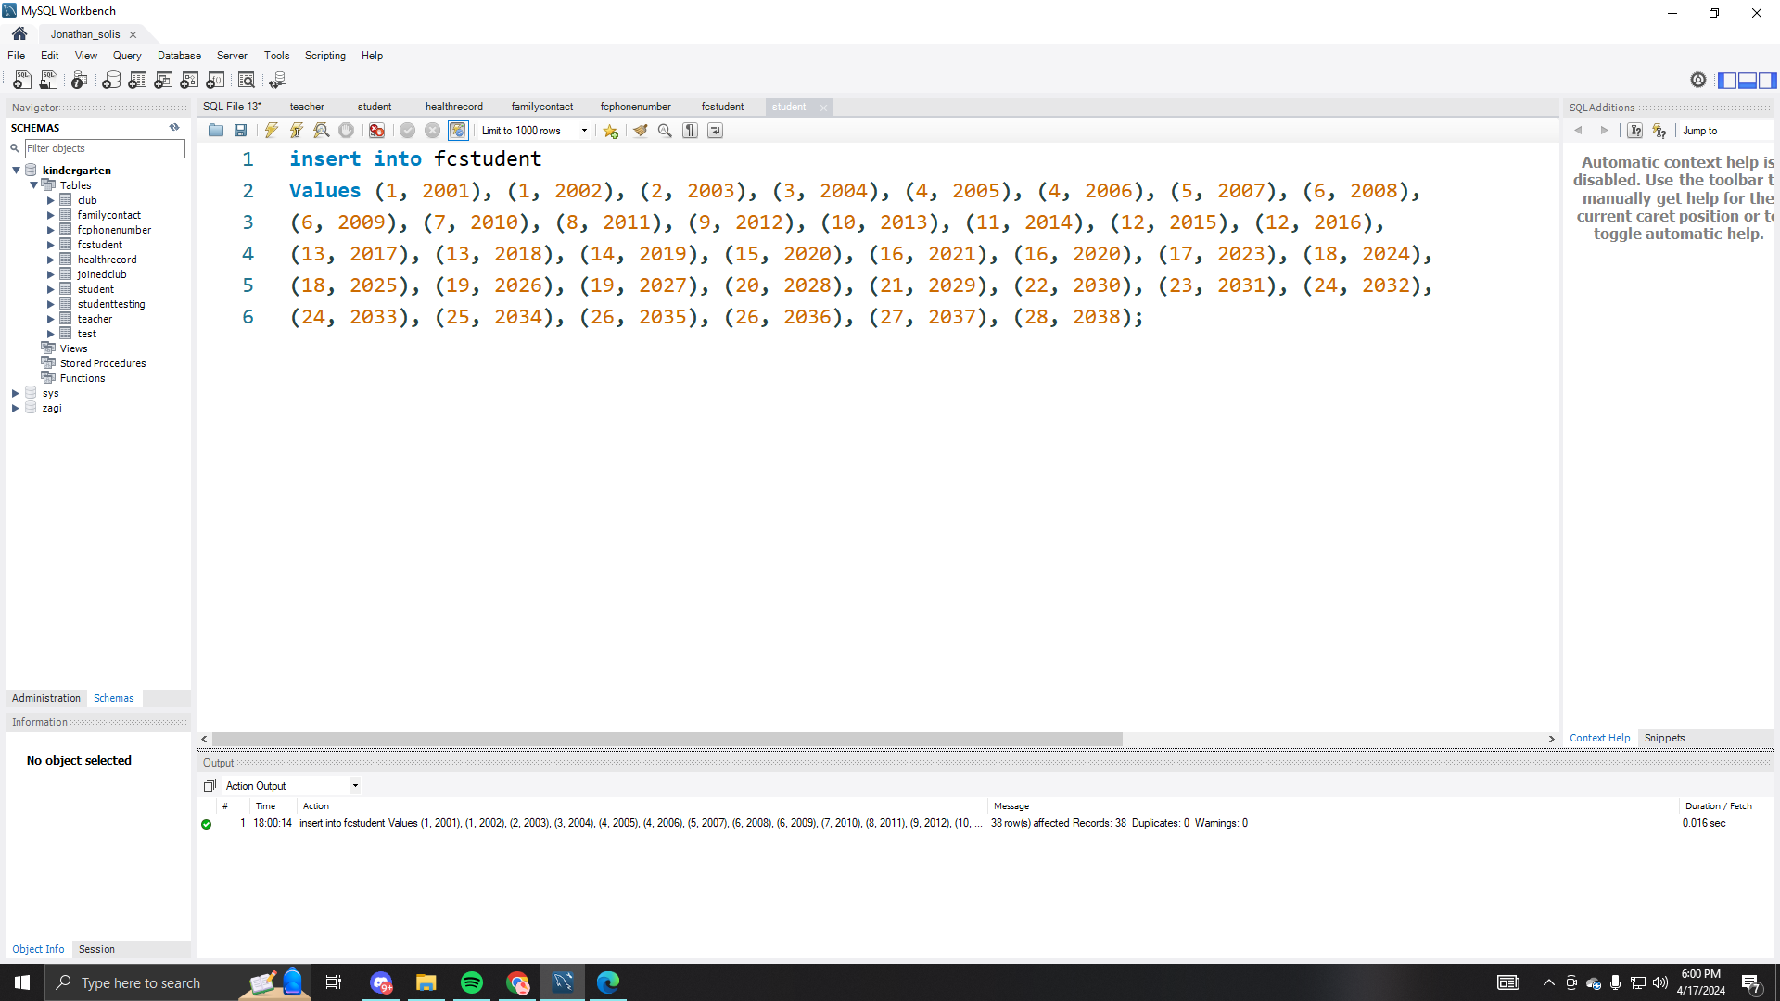

* Test data code.

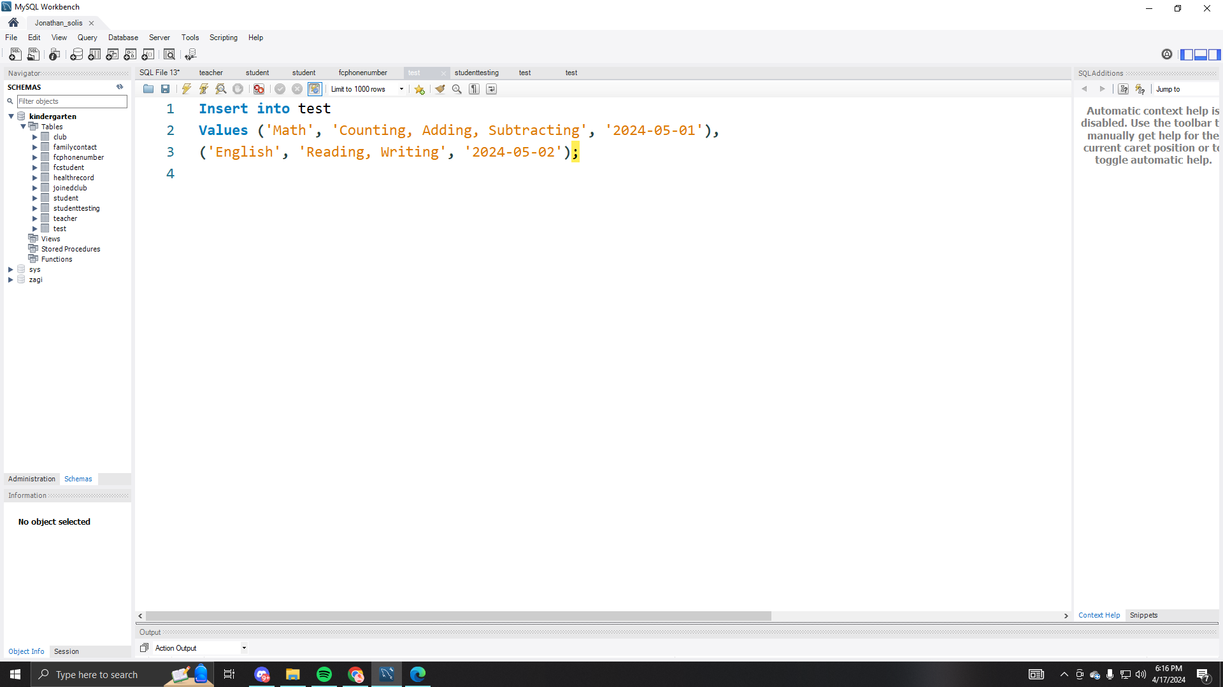

* StudentTesting data code

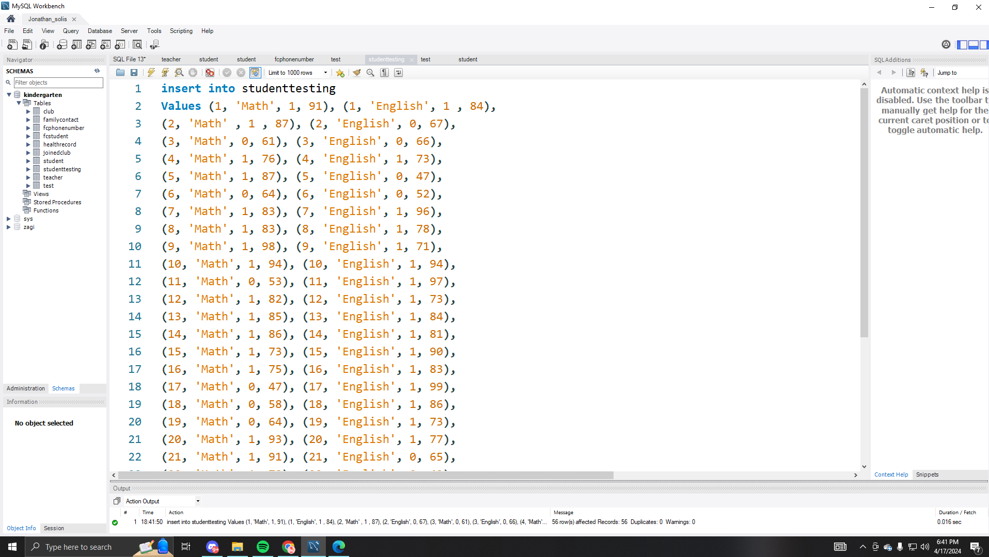

* Club data code.

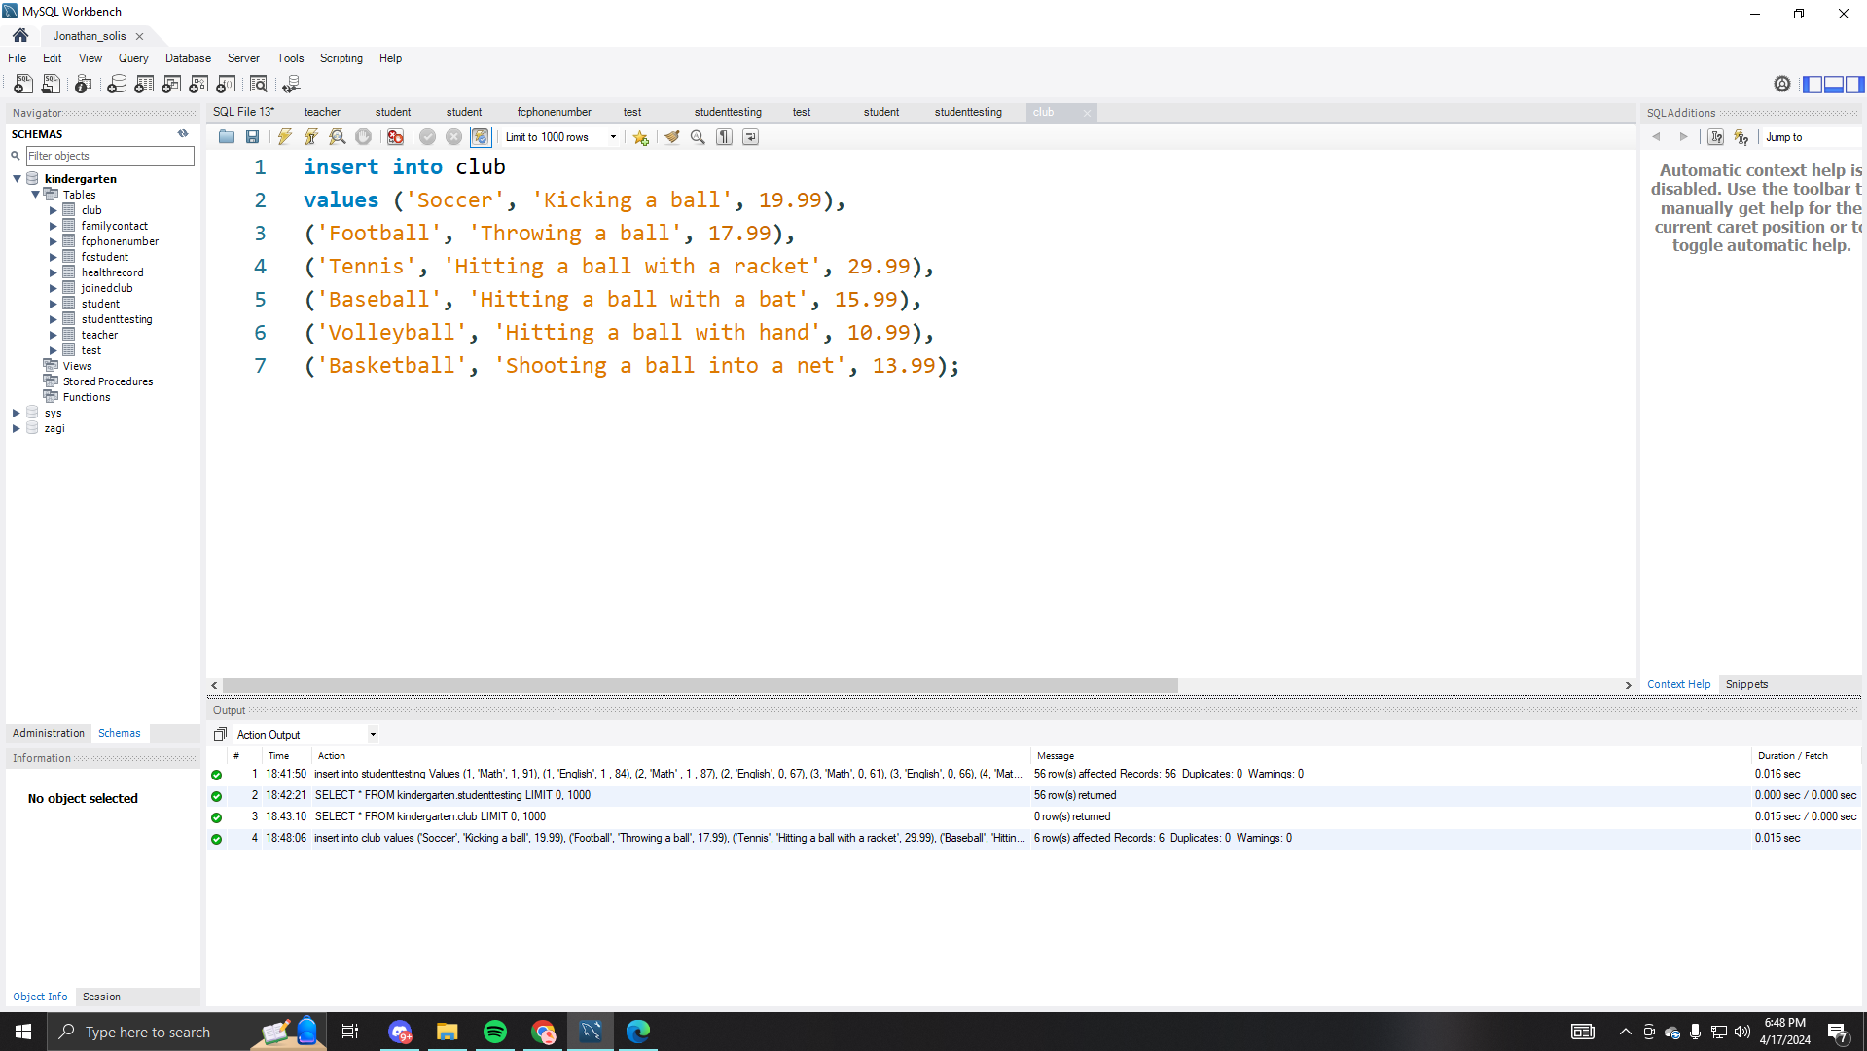

* JoinedClub data code

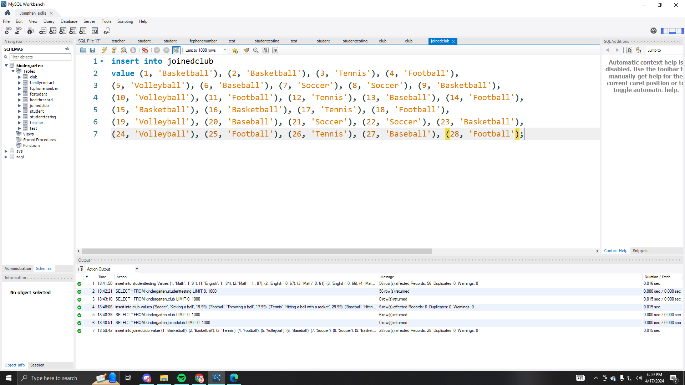

*Use MySQL Server and MySQL Workbench to write/run the SQL queries below. For each query, provide the following in Report 2: Snapshot of the code and the output in the report. In about 2 lines, explain what the query returns.*

**1 trivial query. Simple select with ordering.**

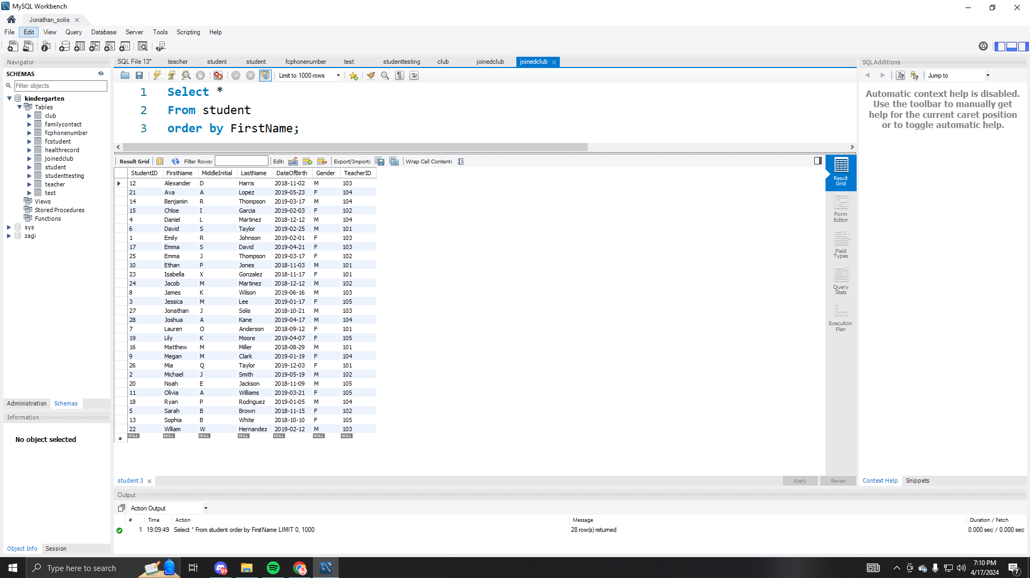

**2 medium difficulty queries. Queries that use composite condition for**

**selection, computations, aggregate function, and grouping.**

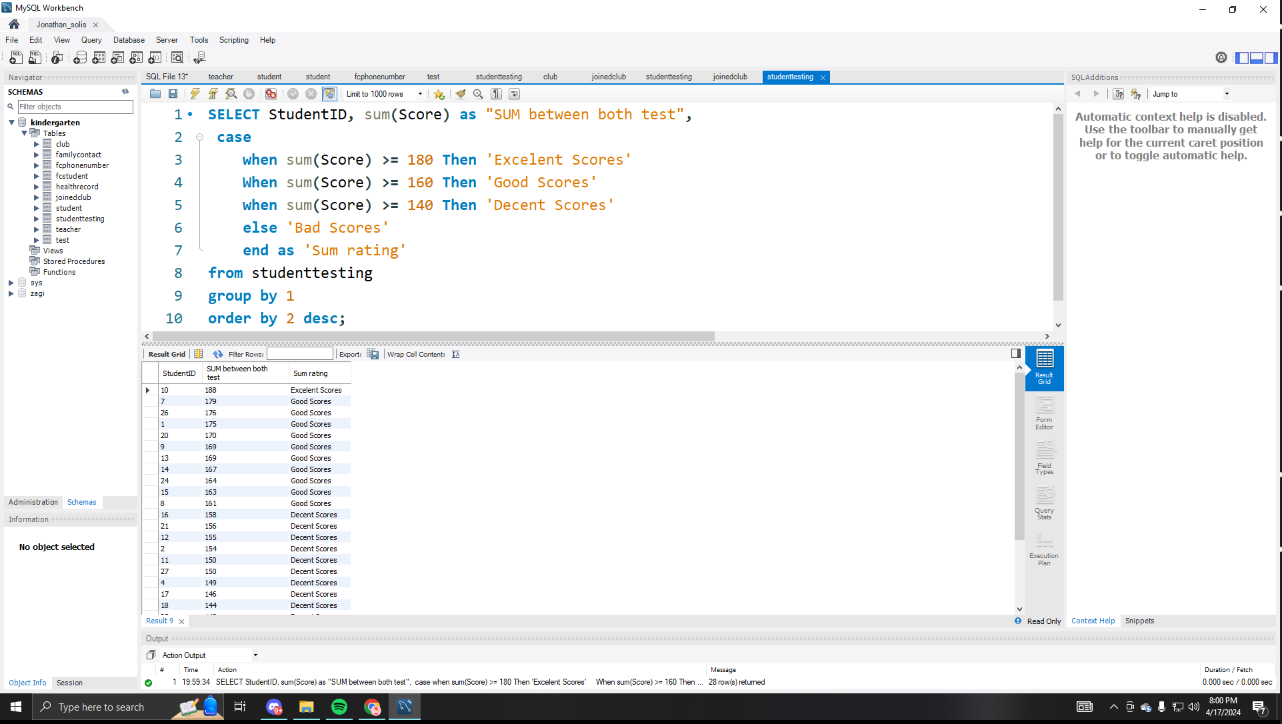

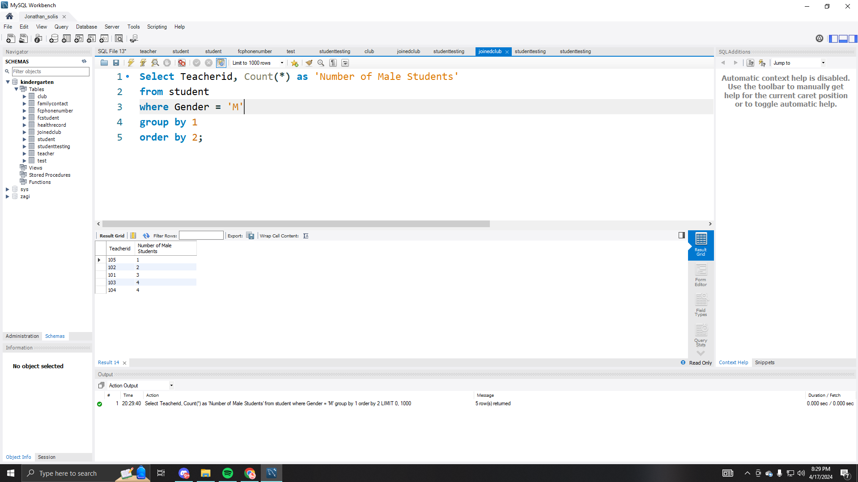

**1 query that uses subquery.**

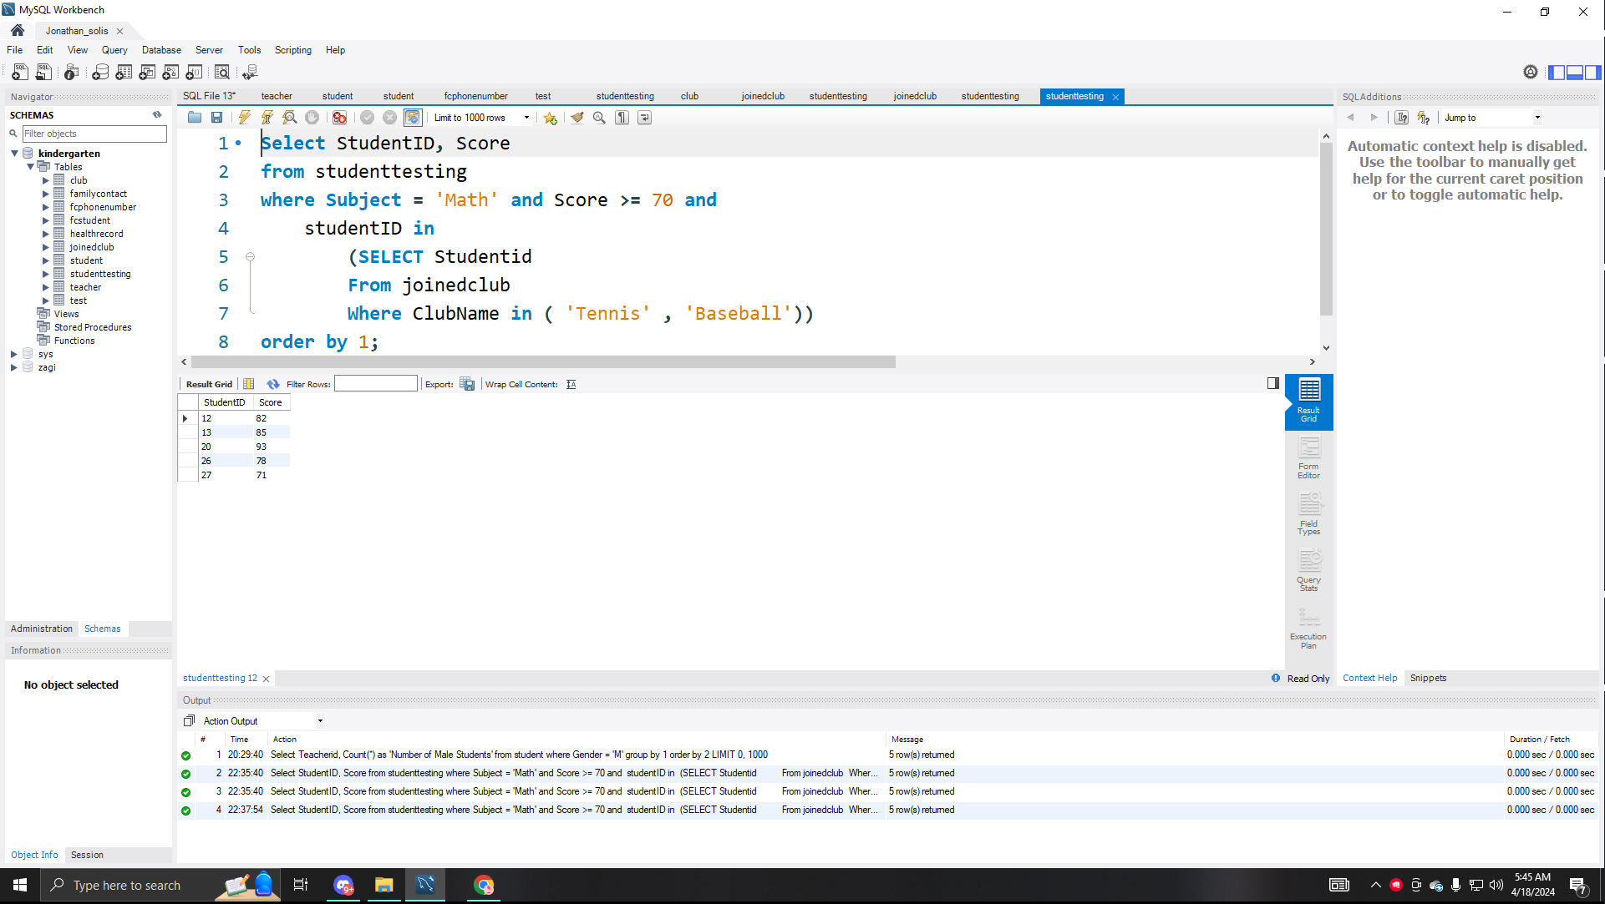

**2 queries that uses join (1 inner join, 1 left or right outer join).**

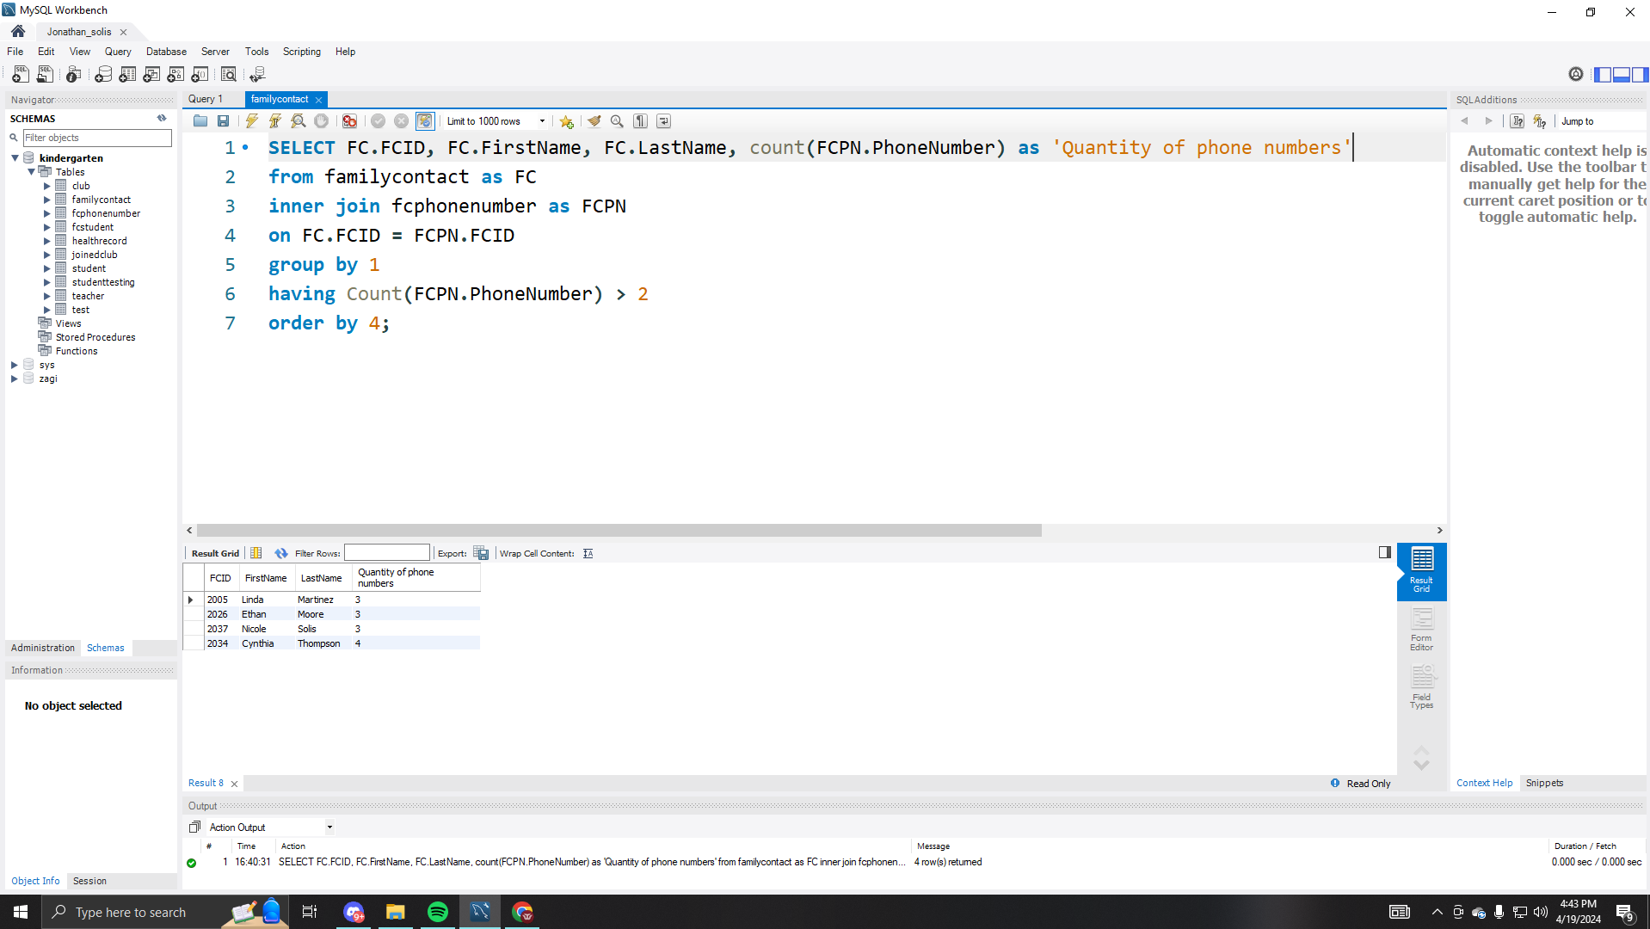

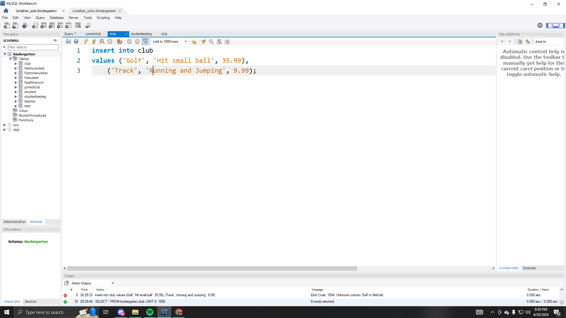

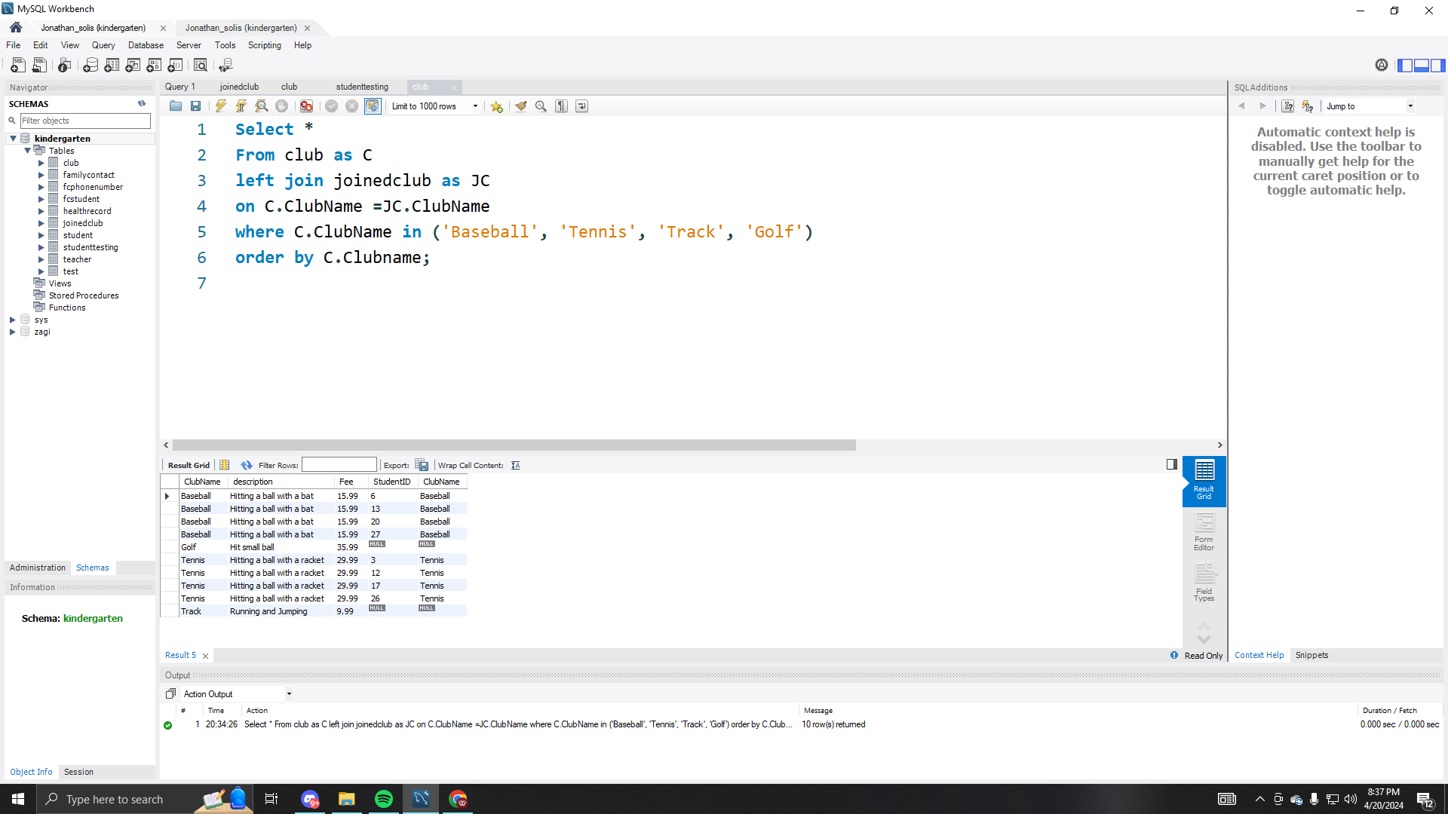

**1 view (query must use join – hint: you can use one of the queries from the**

**previous question).**

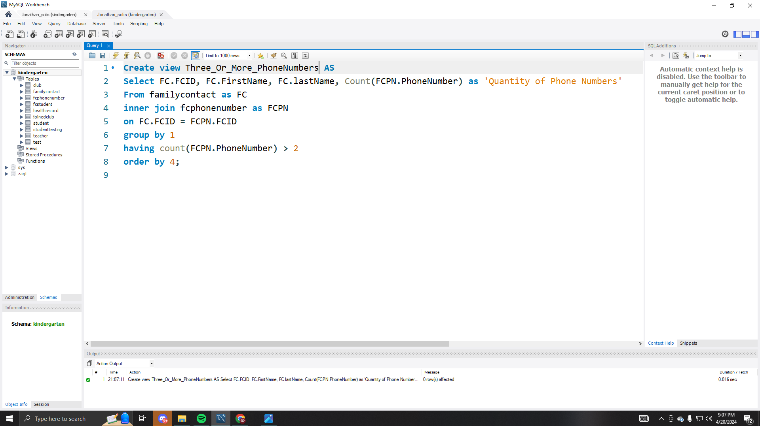

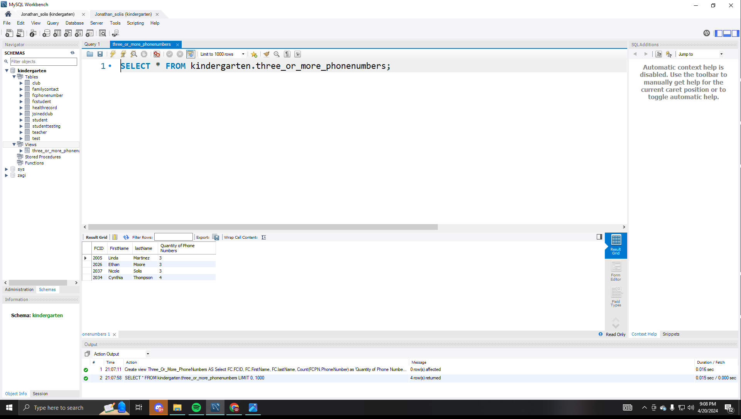

**1 query that uses union.**

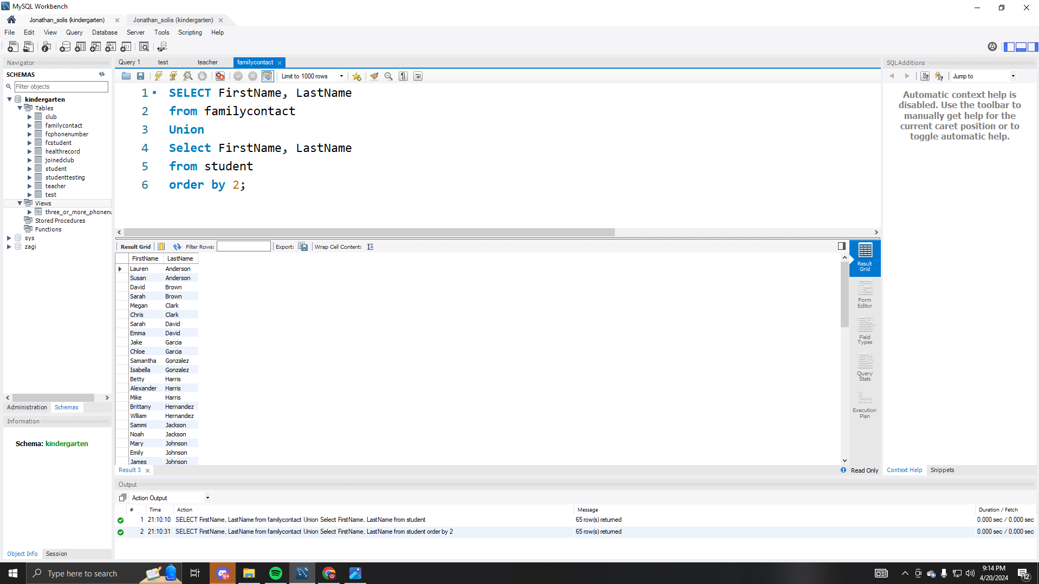

**1 custom stored function.**

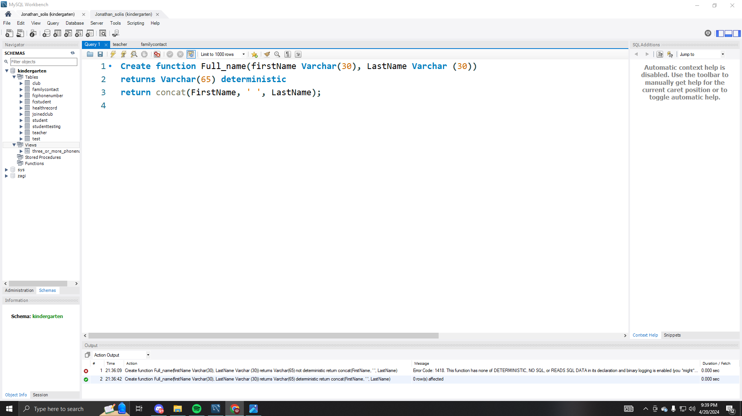

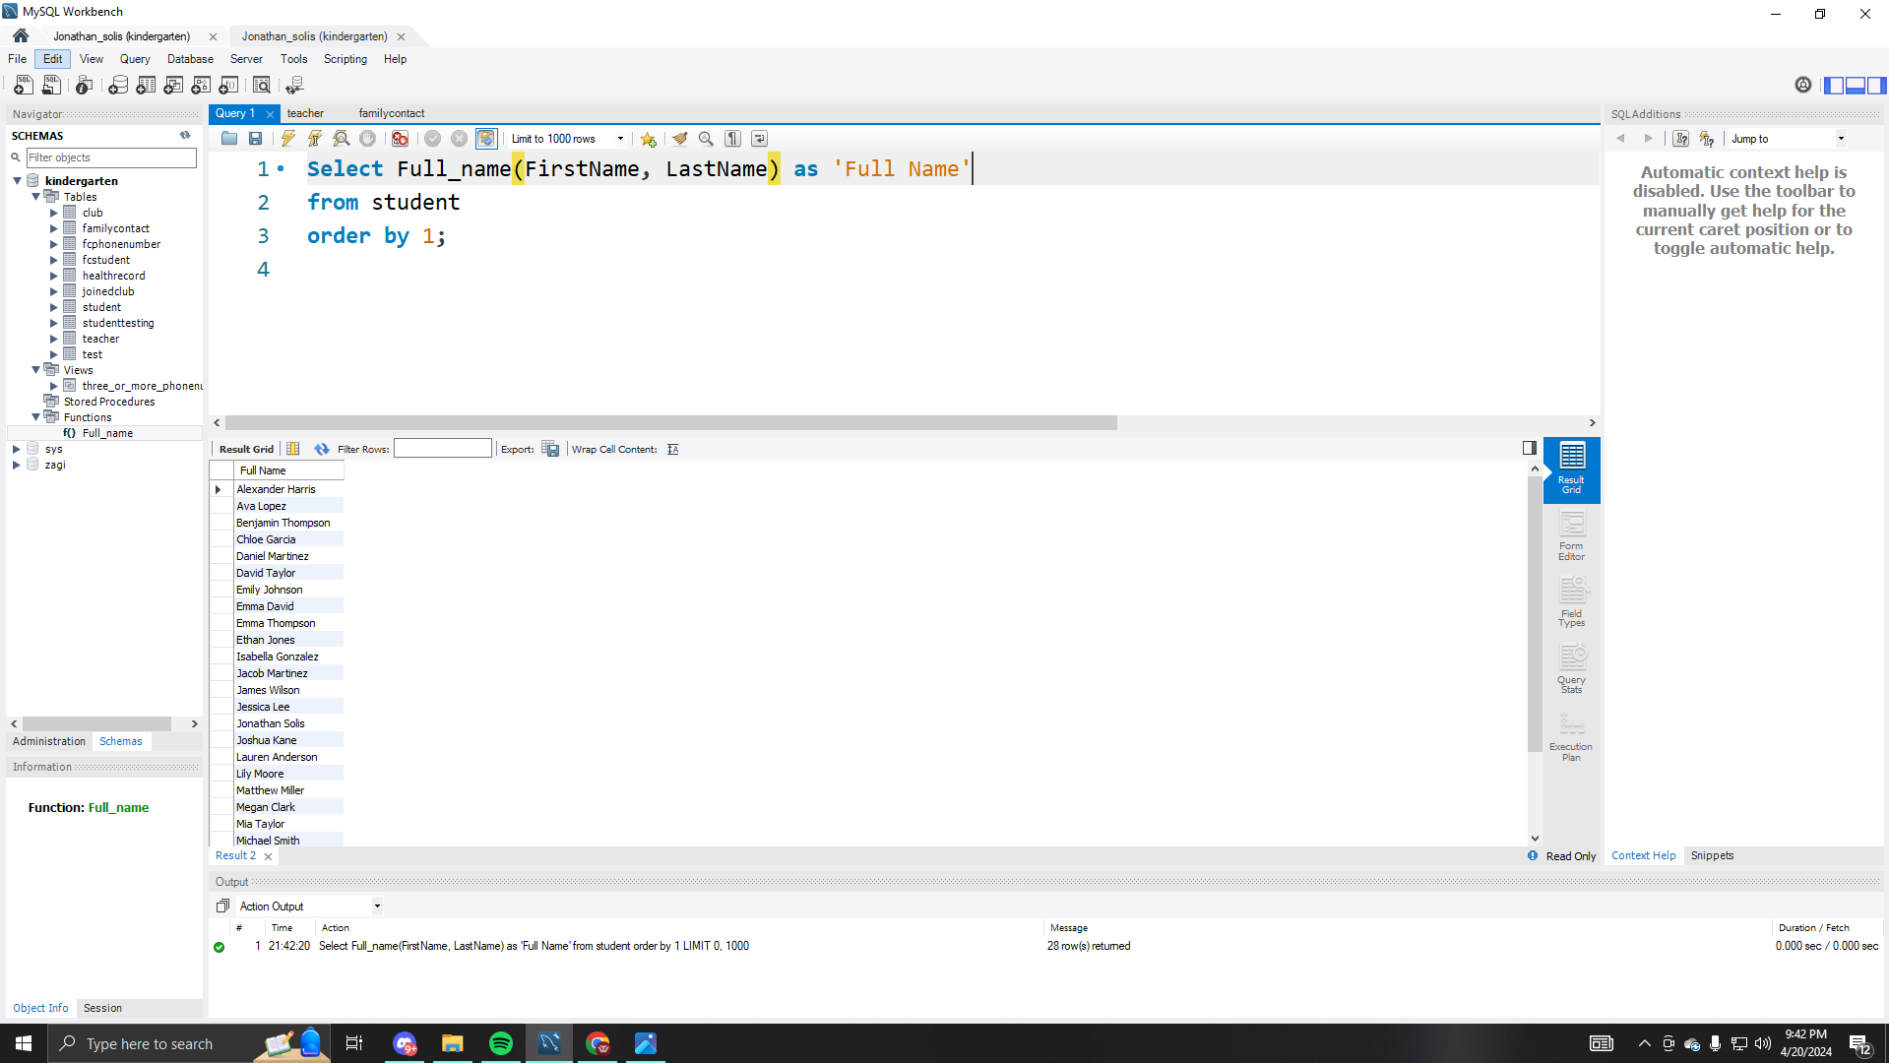

**1 custom stored procedure.**

